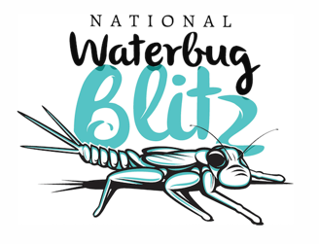

National Waterbug Blitz 2018 - Key Messages
Our waterways under the magnifying glass

- The wellbeing of our freshwater ecosystems is vitally important, and this project will help us look after them.
- "Water not only provides habitat and food for our wildlife, it's also crucial for the economy with a major role across a range of industries including agriculture and tourism."

- "After each National Waterbug Blitz, an interpretive annual report and map of river health across the nation will be created by freshwater ecology specialists, which catchment managers can use to better maintain or improve the condition of our waterways."

- "The method is non-harmful to the waterbugs; they're all returned to the water safe and sound."

- Everyone can get involved to help put our waterways under the magnifying glass by collecting valuable data.
- "The National Waterbug Blitz is Australia’s first citizen science based national river health monitoring system of its kind."
- "Participants will use a mix of basic tools (hand lens, ice-cube tray and plastic spoon) and The Waterbug App, to identify live waterbugs, and upload the information to a national waterbug database."
- "The program ensures citizen scientists collect robust data, with quality assurance measures incorporated into the process to ensure confidence in the results. Sampling follows standardised methods, teaching the importance of quality assurance and quality control, with accreditation of participants an option."

- Citizen science isn't just great for the environment - it's fun, good for you and good for the community.
- "Learning about freshwater ecosystems can be fun, easy and enjoyed by all. The National Waterbug Blitz encourages participants to get outdoors, spend time in nature, discover and explore – improving the health of themselves and their environment."

- "Learning about freshwater ecosystems boosts understanding of STEM subjects. The program is an opportunity for accessible, scientific, hands-on, user-friendly learning for all ages and experience levels."

