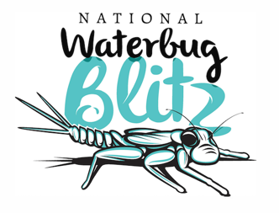
DATE
ADDRESS

Dear Mr/Ms [SURNAME],

In spring this year, a collaboration of scientific bodies including Waterwatch Victoria and Waterwatch NSW will be launching an inaugural nationwide survey of our waterways, with the help of thousands of everyday Australians and funding from the Australian Government’s Inspiring Australia Grants Program.

The 2018 National Waterbug Blitz will be the first citizen science based national river health monitoring system of its kind, to be shared and utilised in the future by the broader community, catchment managers and scientists to focus on-the-ground action to improve our nation’s waterways.

In spring each year, participants from all around Australia - and hopefully residents from your electorate - can discover how healthy their local waterways and wetlands are, using innovative methods developed specifically for citizen scientists. The method is non-harmful to the waterbugs, who all get to go back into the water safe and sound.

This is a great opportunity for residents in your electorate to learn more about their wonderful natural environment, encourage community building activities and to work together to help our scientists better understand our waterways.

We would love to have your involvement and are keen to collaborate on media initiatives to help raise the profile of the blitz and the groups and individuals who are participating. We have prepared some media resources including releases and key messages, which you can access on the Waterbug Blitz website here: https://www.waterbugblitz.org.au/Resources

During the Blitz period in spring 2018, there will be hundreds of events run across the country. We are encouraging members of Parliament to get involved with local organisations that are hosting river explorations and group training sessions. This is a good news story that we believe will be of great interest to a wide range of news media outlets across the country and we would be delighted to encourage as many parliamentarians as possible to make use of the media resources on the website to create and distribute releases announcing their support of the program.

Our waterways are critical to our communities, economy, agriculture, recreation and ecosystems and their continued good health is intrinsically linked to the wellbeing of our nation. An interpretive annual report and map of river health across the nation will be created by scientists and freshwater ecology specialists, after each National Waterbug Blitz, which catchment and other land managers can use to identify trends in the ecological state of freshwater systems.

We are encouraging local members to reach out to their constituents and help spread the word about the Blitz. The project is a fun and easy way for people in your electorate to learn about freshwater ecosystems, and a great way to contribute to the future wellbeing of our nation. The National Waterbug Blitz is a wonderful opportunity to get outdoors, spend time in nature, discover and explore – work on improving the health of yourself and the environment.

To discuss the program further, please contact [CONTACT NAME].

Yours faithfully,
[YOUR NAME]

